Foliotek (for Faculty): How to Place a Foliotek Link in a Course

In order for your students to access Foliotek, you need to place a link to it in the course menu. This help sheet lays out the process for doing so.

Process Steps:
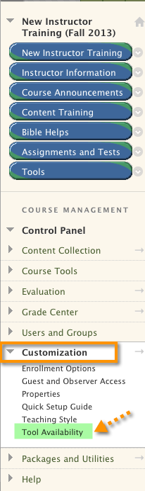
- Make sure that the Foliotek tool is turned on in your course. To get started, go to the course Control Panel and, from the “Customization” section choose “Tool Availability.”

- This takes you to a page where you can turn tools on and off for your course. Scroll down until you reach “Foliotek E-Portfolio Tool” and make sure the box to the right of the name is checked, which will make the tool available if it wasn’t previously. Click “Submit” at the bottom of the page to save your change.
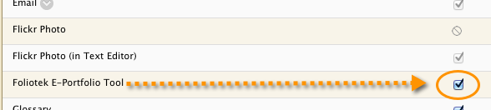

(Continued on next page)
- Now you can add a link to the Foliotek Tool to your course menu. To begin, click the “+” above the menu (1) to get a drop-down list of things that can be added to the course menu. Then, click on “Tool Link” (2) to select it.
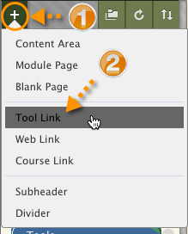

- You will be taken to a page to enter information about the link. Follow these steps: (1) Type the name you want to use for the tool in the “Name” field—probably “Foliotek Tool” or “E-Portfolio Tool” will be most recognizable to your students. (2) From the “Type” drop-down menu select “Foliotek E-Portfolio Tool.” (3) Click the box next to “Available to Users” to make the new menu item visible to students. (4) Click “Submit” to save your work.
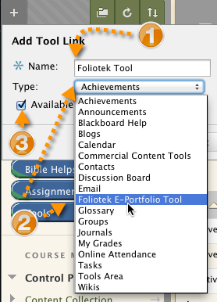

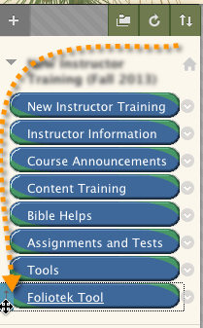
- The new item appears at the bottom of your course menu. You can use Blackboard’s drag-and-drop functionality to move the item to the appropriate place in your course menu. Position your cursor to the left of the menu item until you see the cursor type change; then, drag the item to its new position.

Now your students can complete their Foliotek assignments.

