Foliotek (for Students): How to Access Your Foliotek Account

Foliotek is an online portfolio system (e-portfolio) used to organize a collection of work you have done, somewhat like an old-fashioned scrapbook. This help sheet explains how to access Foliotek and register your license, which Moody has already purchased for you.

Process Steps:
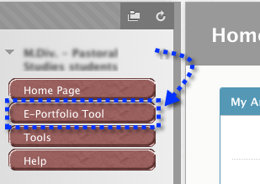
- Go to the Blackboard course site that contains your e-portfolio assignment and, from the course menu, click the link titled “E-Portfolio Tool.”

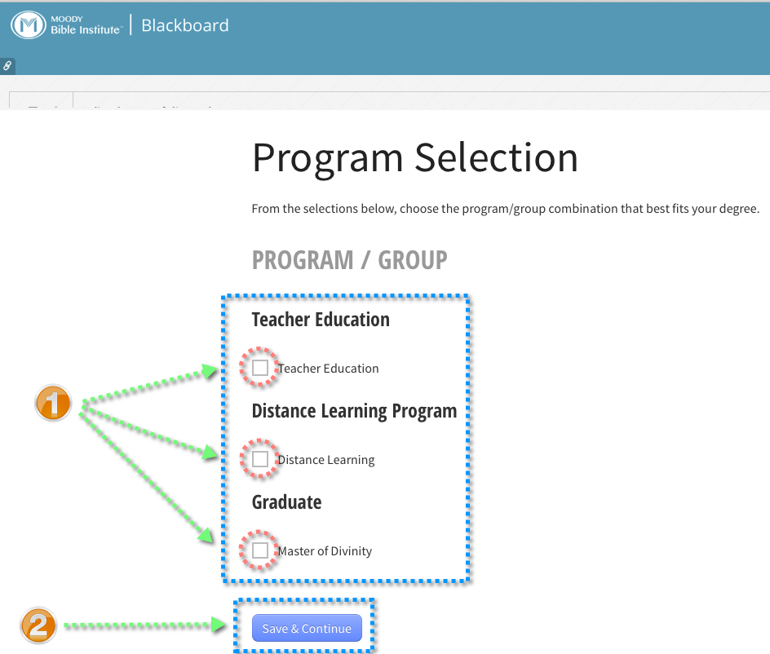
- This takes you to a page where you select the program in which you are enrolled. Click the box next to your program, and click the “Save and Continue” button to move to the next page. (If you are in an online MTS program, choose a selection in the “Graduate” section rather than from “Distance Learning Program.”

(Continued on next page)
- In order to use the e-portfolio, you will need to accept the user agreement that appears on this page. Read the agreement (1), type in your initials (2), click next to the option that indicates that you accept the agreement (3), and click “Next” (4) to move to the next page.
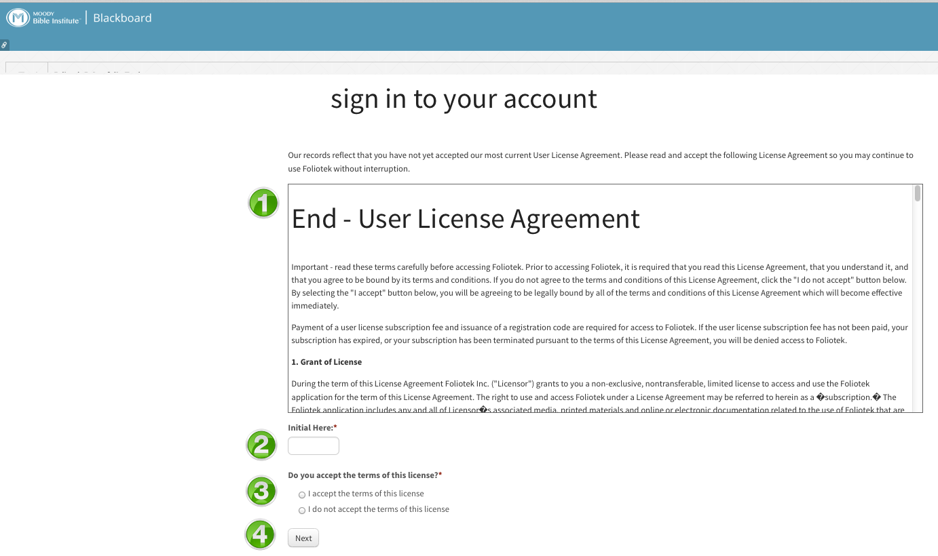

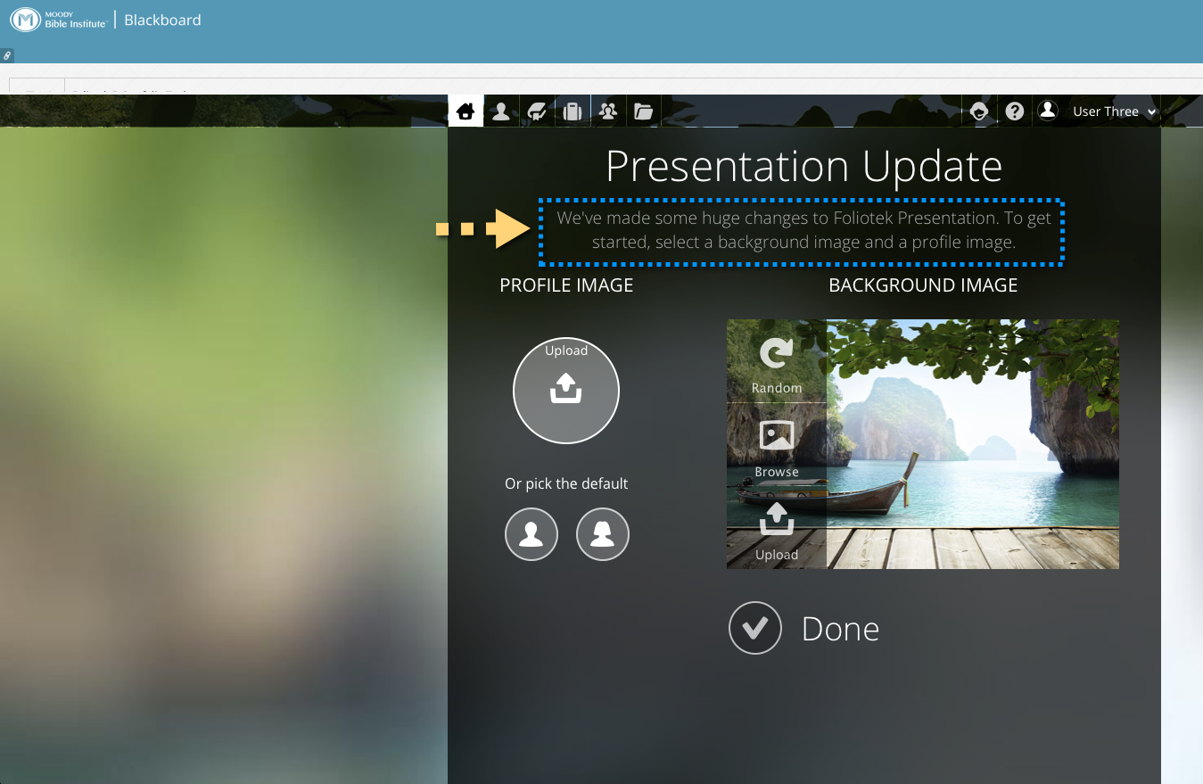
- You will now be taken to your Foliotek home page. You will be prompted to begin personalizing your Foliotek experience by choosing a background image for your portfolio and an image for your profile. Click “Done” when you are finished.

(Continued on next page)
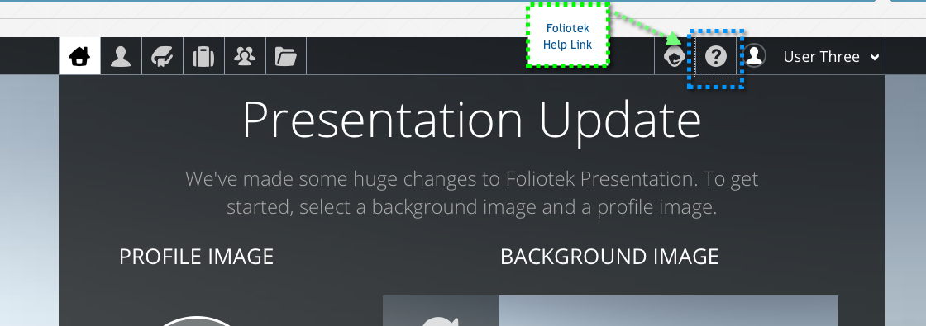
- Foliotek has many features for building an e-portfolio that you can customize to be just what you want. In order to help you learn how to use these features, many help resources have been provided. Click the “?” icon to access the help page.

- The help page is pretty comprehensive in explaining the main features you will use with Foliotek. If you have additional “ how to” questions, please contact a Foliotek help representative per the information given on the help page. Because Foliotek currently is not used campus-wide, ITS has chosen to contract with Foliotek to provide user support.
